Name: _______________________ Class: __________ Date: _______
Instructions: Write answers in the right-hand column. Score: ___________ / 25 marks

Section A—Multiple choice (5marks)

 | The relative atomic masses of carbon and magnesium are approximately 12 and 24 respectively. Which one of the following statements is true?  A A carbon atom has half the mass of a magnesium atom.  B An atom of carbon has a mass of 12 g and an atom of magnesium has a mass of 24 g.  C Because the atomic mass ratio is 1:2, carbon and magnesium would combine to form the compound Mg₂C.  D A magnesium atom has 12 more protons than a carbon atom. | A | 1
 | Rubidium occurs in nature as a mixture of two isotopes with atomic masses of 85.02 and 87.01. What approximate percentage of each isotope must be present if the atomic mass of the element rubidium is 85.47?  A 25% Rb-85, 75% Rb-87  B 50% Rb-85, 50% Rb-87  C 70% Rb-85, 30% Rb-87  D 95% Rb-85, 5% Rb-87 | C | 1
 | Four students were required to determine the calcium ion content in a sample of limestone. The answers they obtained are given below. Which of these answers could not possibly be correct?  A 0.012 mol of calcium ions  B 2.4 × 10^{–2} calcium ions  C 0.47 g of calcium ions  D 5.3 × 10²¹ calcium ions. | B | 1
 | 28 g of nitrogen gas (N₂):  A contains 6.02 × 10²³ atoms of nitrogen  B contains 6.02 × 10²³ molecules of nitrogen  C contains two mole of nitrogen molecules  D is heavier than 28 g of hydrogen. | B | 1
 | Which of the following would have the largest mass?  A 50.0 g of sodium chloride  B 1.50 mol of sodium chloride  C 6.02 × 10²² formula units of sodium chloride  D the mass of sodium chloride that contains 1 mol of chloride ions. | B | 1

Section B—Written answers (20 marks)

 | a Calculate the amount, in mol, of aluminium ions in 100 g of aluminium sulfate.  b What is the mass of 9.23 × 10²² formula units of lead(II) permanganate? | a n(Al₂(SO₄)₃ = 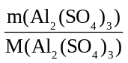  M(Al₂(SO₄)₃ = 342.14 g mol^{–1}  n(Al₂(SO₄)₃ = 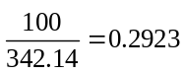mol  n(Al³⁺) = 2 × n(Al₂(SO₄)₃) = 0.585 mol  b 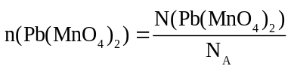  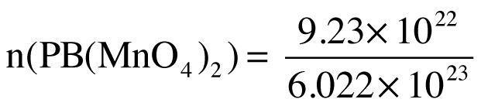  = 0.1533 mol  mass(Pb(MnO₄)₂) = n × M(Pb(MnO₄)₂)  M(Pb(MnO₄)₂) = 445.08 g mol^{–1}  mass(Pb(MnO₄)₂) = 0.1533 × 445.08  = 68.2 g | 6
 | A student places 10.0 g of iodine, I₂, in a beaker and then gently heats the beaker. 0.00970 mole of the iodine sublimes into the atmosphere during the heating. How many molecules of iodine, I₂, remain in the beaker after heating? | n(I₂) present at start = 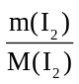  = 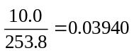mol  n(I₂) remaining = 0.03940 – 0.00970  = 0.02970 mol  number of molecules remaining = n × N_{A}  = 0.02970 × 6.022 × 10²³  = 1.79 × 10²² | 3
 | One atom of element X has a mass of  4.48 × 10^{–23} g.  a What is the molar mass of the element X?  b Identify element X. | a 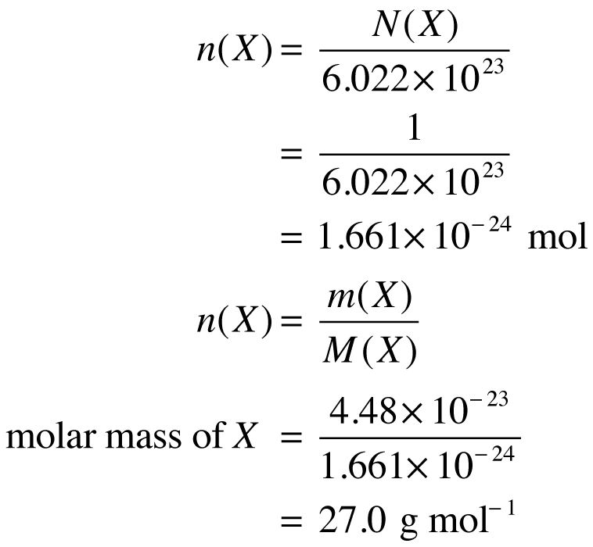  b Element X is aluminium, | 3
 | 18.9 g of NaCl and 0.256 mole of MgCl₂ are dissolved in water in a beaker. How many chloride ions are present in the water in the beaker? | 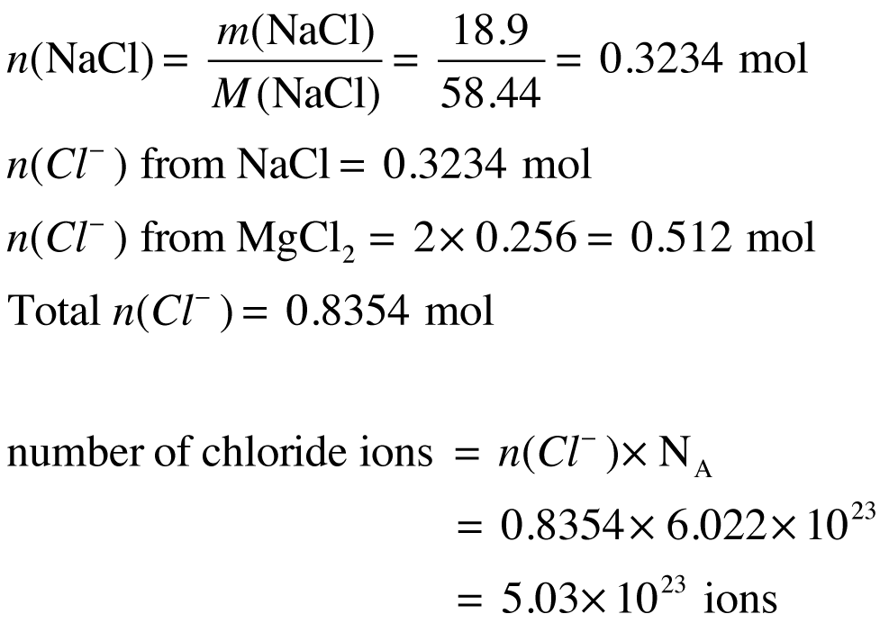 | 4
 | Which of the compounds, NH₄NO₃ or Ca₃N₂, has the larger percentage, by mass, of nitrogen? | 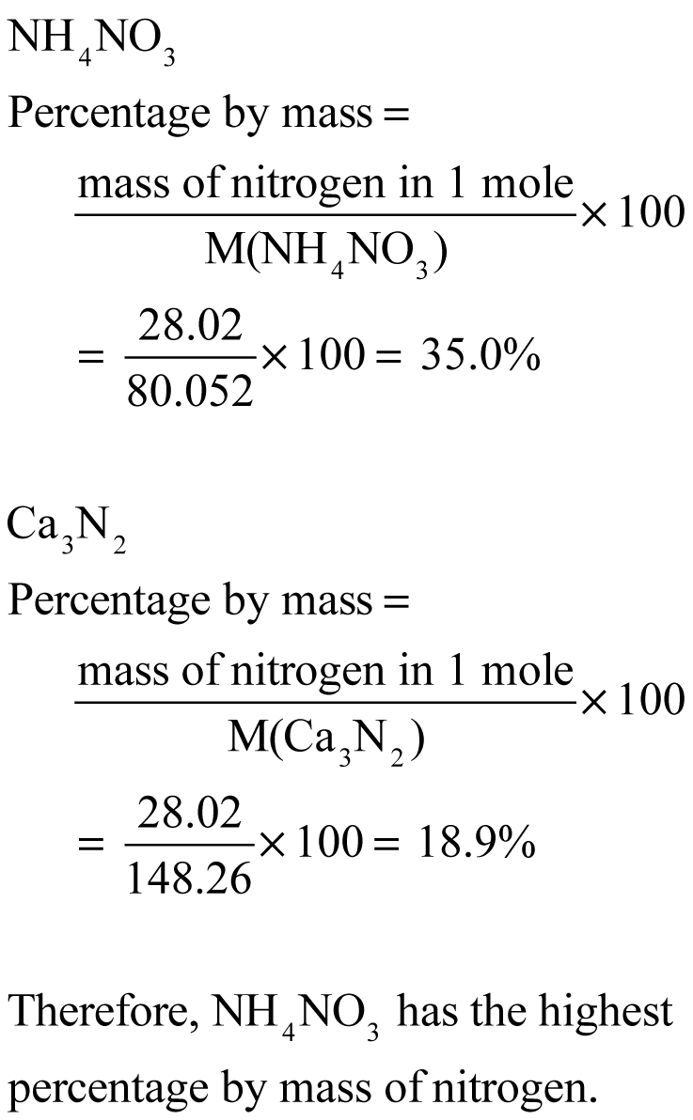 | 4

